

EC-200 Data Structures
LAB MANUAL # 04

Course Instructor: Dr. Anum Abdul Salam

Lab Engineer: Engineer Hira Irshad

Student Name: _______________________________________________

Degree/ Syndicate: ____________________________________________

 | Trait | Obtained Marks | Maximum Marks
R1 | Application Functionality 20% |  | 20
R2 | Specification & Data structure implementation  30% |  | 30
R3 | Reusability  10% |  | 10
R4 | Input Validation  10% |  | 10
R5 | Efficiency  20% |  | 20
R6 | Delivery  10% |  | 10
R7 | Plagiarism above 60% |  | 0
 | Total |  | 100

Total Marks = O𝒃𝒕𝒂𝒊𝒏𝒆𝒅 𝑴𝒂𝒓𝒌𝒔 (∑⁶_{𝟏} 𝑹_{𝒊} ∗ 𝑹₇)
Lab #04: Implementation of Queues and Stacks

Lab Objective:
To implement queues and stacks in C++.
Lab Description:

Queue:
A queue is a container in which insertions are made at end and deletions are done from start. Queue is a First in First out (FIFO) data structure. Unlike stacks, queue allows insertion from end and deletion from start. Like stacks queue can be implemented using
- Dynamic Approach (using Lists)
- Static Approach (using arrays)
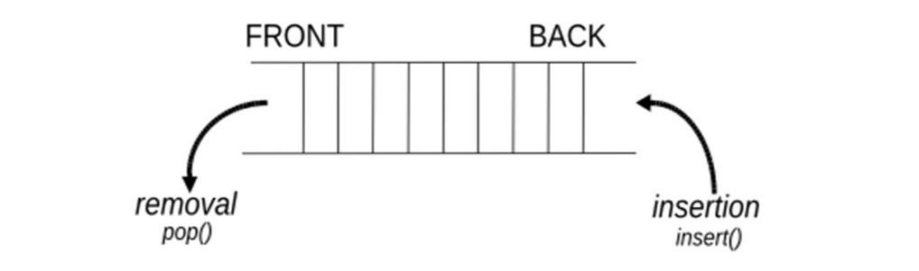
Figure 4.1: Queue Representation
Application of Queues:
- In operating systems, for controlling access to shared system resources such as printers, files, communication lines, disks and tapes. A specific example of print queues follows:
a. In the situation where there are multiple users or a networked computer system, you probably share a printer with other users. When you request to print a file, your request is added to the print queue. When your request reaches the front of the print queue, your file is printed. This ensures that only one person at a time has access to the printer and that this access is given on a first-come, first-served basis.

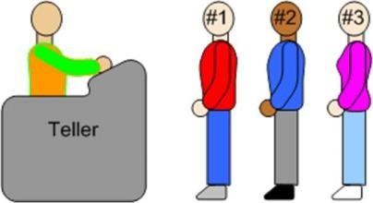

Figure 6.2: Queue Simulation in real life Scenario
- For simulation of real-world situations. For instance, a new bank may want to know how many tellers to install. The goal is to service each customer within a "reasonable" wait time, but not have too many tellers for the number of customers. To find out a good number of tellers, they can run a computer simulation of typical customer transactions using queues to represent the waiting customers.
- When data is transferred asynchronously (data not necessarily received at same rate as sent) between two processes. Examples include IO Buffers, pipes, file IO, etc.
Dynamic Queue:
Insertion and deletion of dynamic queue is same like insert at end (enqueue) and delete at start (dequeue) in single LinkedList.
Operations:
Queue ADT should provide following functions.
- Enqueue (insert at start)
- Dequeue (delete from start)
- Is Empty (to check is queue isempty)
- Display (get front element of queue)
v. Copy Constructor (for deep copying queue) vi. Destructor (De allocating queue memory)
vii. Default constructor
Stack:
A stack is a restricted linear list. All additions and deletions are made at one end, the top. Stacks are known as last in, first out (LIFO) data structures. Stacks can be implemented using:
- Dynamic Approach (using lists)
- Static Approach (using arrays)
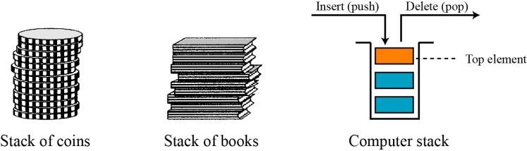
Figure 5.1 Stack Representation

Application of Stacks:
- Backtracking. (Function calls, Undo Redo operations)
- Infix to postfix conversions

LAB TASK:
Note: Implement the following tasks using templates. Use the Queue and Stack ADT you have already implemented in class task and make it templated.

1. A simple computing system has a single processing unit that handles tasks submitted by users. Tasks arrive in a given order and must be handled strictly in the same order they are received. The processor can work on only one task at a time. If additional tasks arrive while a task is being handled, they must wait their turn until the processor becomes free.
Each task should contain:
- Task ID
- Required work units (number of processing steps needed to finish the task)
Tasks are provided in a fixed order and stored in the system. The processor always works on the next task waiting in line. Each processing action reduces the remaining work of the current task by one unit. When a task’s work reaches zero, it is removed from the processor and recorded as completed. The processor then immediately begins the next available task. The simulation ends when no tasks remain to be processed.
You have to maintain:
- A collection of tasks waiting to be handled
- The task currently being processed
- A record of tasks that have finished
All tasks must be handled in first-come, first-served order.
Your program should allow:
- Adding new tasks to the system
- Processing one step of the current task
- Showing which task is currently being handled
- Displaying all tasks still waiting
- Displaying completed tasks
- Processing all remaining tasks until the system becomes empty

2. You are building a simple canvas editor that keeps a list of shapes. Users can add a shape, remove the most recent shape, and undo or redo their actions. The system must correctly move backward and forward through the editing history.
The canvas stores shapes in order. Each shape needs:
- Shape ID
- Shape type (Circle / Rectangle / TextBox)
Your program must support:
- Add Shape
Add a new shape to the canvas.
- Delete Last Shape
Remove the most recently added shape.
- Undo
Reverse the most recent add/delete operation.
- Redo
Re-apply the most recently undone operation. Redo cannot be used if no actions have been undone. If a new action (add/delete) is performed after an undo, the redo history is cleared, and redo cannot be performed until another undo is done.
- Display Canvas
Show all shapes currently on the canvas.

THINK:
- Why is rear maintained in queue to save address of last node?
- What is the difference between queue and linked list?
- In what scenario do you prefer using static stack implementation?

